EXPT NO: 7 | TEXT PREPROCESSING AND EMBEDDING GENERATION USING NLP LIBRARIES
DATE: 11-10-2026

PRE-LAB QUESTIONS (PROVIDE BRIEF ANSWERS TO THE FOLLOWING QUESTIONS)

1. Explain the importance of text preprocessing in Natural Language Processing.
Text preprocessing cleans and prepares raw text for analysis. It includes lowercasing, tokenization, punctuation removal, stop-word removal, and lemmatization. It improves the quality of text data for NLP tasks.

2. Differentiate between tokenization, stemming and lemmatization.
Tokenization: Splits text into smaller units, such as words or sentences.
Stemming: Removes word endings to obtain a root form, which may not be a proper word.
Lemmatization: Converts words into their meaningful base form using linguistic rules.

3. Explain the purpose of stop-word removal in text preprocessing.
Stop-word removal eliminates common words such as “is,” “the,” and “and” that may contribute less useful information to a particular task. It reduces the text size and helps focus on meaningful words

4. Describe word embeddings and their significance in deep learning.
Word embeddings represent words as dense numerical vectors. They help deep learning models capture semantic relationships between words and process textual data effectively.

5. Explain how Word2Vec represents words as dense numerical vectors.
Word2Vec learns a numerical vector for each word based on its surrounding context in a text corpus. Words used in similar contexts tend to have similar vector representations.

AIM
To perform text preprocessing using NLTK and generate word embeddings using Gensim Word2Vec to analyze semantic relationships between words.

SOFTWARE REQUIREMENTS
- Python
- NLTK
- Gensim
- NumPy
- Google Colab
- GitHub

OBJECTIVES
Students will be able to:
- Understand the architecture and working of Recurrent Neural Networks (RNNs).
- Perform text preprocessing techniques for sequence modeling.
- Generate input sequences suitable for training an RNN model.
- Build and train an RNN model for text generation.
- Generate text by predicting the next word in a sequence.
- Evaluate the performance of the trained RNN using generated text.
- Analyze the effectiveness of RNNs in learning sequential patterns from textual data.

PROCEDURE
PART A: DATASET PREPARATION AND TEXT PREPROCESSING
Perform the following tasks:
- Load the Brown Corpus available in NLTK and select a suitable text category.
- Examine sample sentences from the selected dataset.
- Convert the text into lowercase.
- Perform word tokenization using NLTK.
- Remove punctuation and stop words.
- Perform lemmatization using WordNetLemmatizer.
- Display the original and preprocessed text.

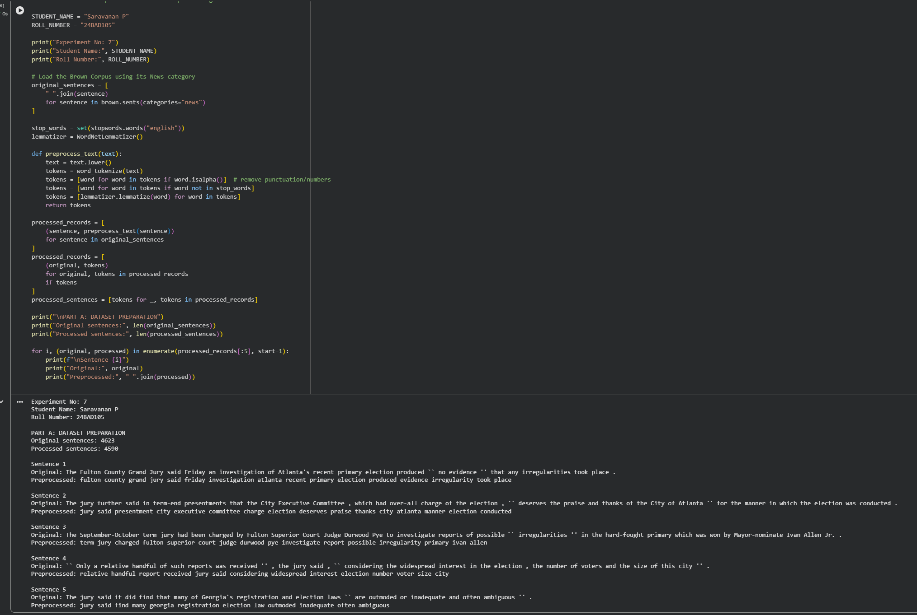

PART B: VOCABULARY GENERATION AND WORD FREQUENCY ANALYSIS
Perform the following tasks:
- Create a vocabulary from the preprocessed text.
- Calculate word frequencies using NLTK's FreqDist.
- Identify the ten most frequently occurring words.
- Display the vocabulary size and frequency distribution.
- Prepare the tokenized sentences for Word2Vec training.

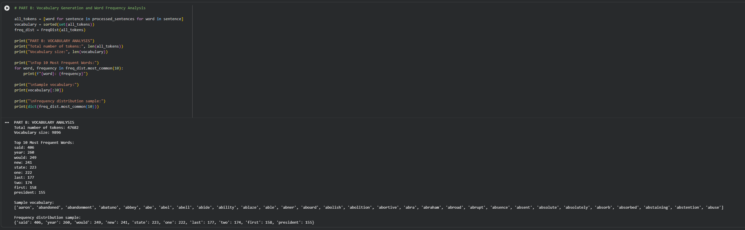

PART C: WORD EMBEDDING GENERATION USING WORD2VEC
Perform the following tasks:
- Train a Word2Vec model using Gensim on the preprocessed sentences.
- Use the Skip-gram architecture with an embedding dimension of 100 and a context-window size of 5.
- Generate embedding vectors for selected words.
- Display the embedding vector and its dimensions.
- Identify the five most similar words for a selected word using the trained model.

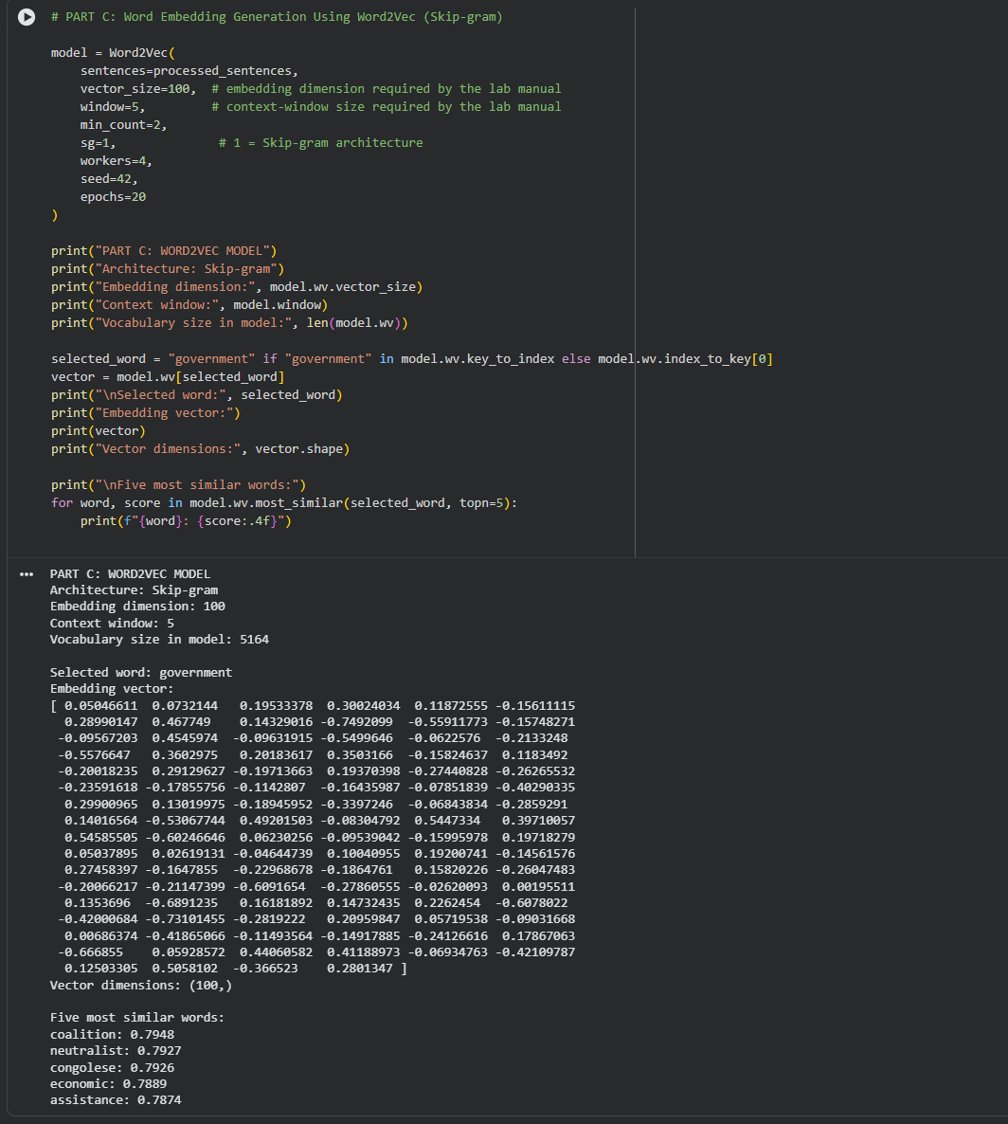

PART D: WORD SIMILARITY ANALYSIS AND EXPERIMENT MANAGEMENT
Perform the following tasks:
- Select three meaningful word pairs from the trained vocabulary.
- Calculate the cosine similarity between each pair using the Word2Vec model.
- Compare the similarity scores and identify the most similar pair.
- Analyze the relationship between contextual similarity and the generated word embeddings.
- Document the observations and upload the completed notebook to GitHub.

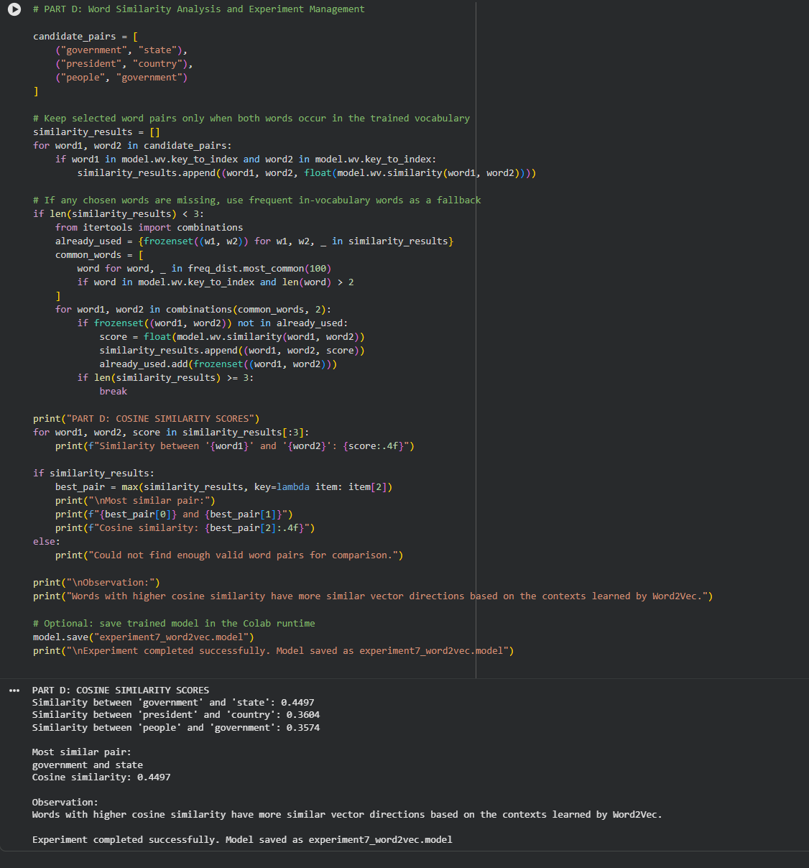

POST-LAB QUESTIONS (PROVIDE BRIEF ANSWERS TO THE FOLLOWING QUESTIONS)

1. Analyze the effect of stop-word removal and lemmatization on the quality of preprocessed text.
Stop-word removal reduces unnecessary words, while lemmatization converts words to their base forms. Together, they reduce text complexity and improve consistency. However, removing stop words may sometimes remove important contextual information.

2. Explain how vocabulary size influences Word2Vec training.
A large vocabulary requires more memory and training time but can represent more words. A smaller vocabulary reduces computational cost but may exclude rare or meaningful words.

3. Compare the CBOW and Skip-gram architectures of Word2Vec.
- CBOW (Continuous Bag of Words): Predicts a target word from its surrounding context words. It is generally faster to train.
- Skip-gram: Predicts surrounding context words from a target word. It often performs better for learning representations of rare words.

4. Analyze how the context-window size affects the generated word embeddings.
A small context window captures nearby, more specific relationships between words. A large context window captures broader relationships and topics but may include less closely related words.

5. Interpret the cosine similarity scores obtained for the selected word pairs.
Cosine similarity measures the similarity between two word vectors. A score closer to 1 indicates high similarity, a score near 0 indicates little directional similarity, and a score closer to −1 indicates opposite directions. Higher scores generally suggest that the words occur in similar contexts.

ASSESSMENT
Description | Max Marks | Marks Awarded
Pre Lab Exercise | 5
In Lab Exercise | 10
Post Lab Exercise | 5
Viva | 10
Total | 30
Faculty Signature

